InGOS – Integrated non-CO₂ Observing System

- Project name (acronym), name and contact information of the researcher(s), duration of the project (dates, number of working days), type and name of the infrastructure requested

Improved flux Prototypes for N₂O emission reduction for Agriculture (IPNOA)
Giorgio Virgili g.virgili@westsystems.com
24th-28th June 2013 (5 days)
Access to Easter Bush measurement site.

- Background

The Europe 2020 Strategy for smart, sustainable and inclusive growth includes five headline targets that set out where the EU should be in 2020. One of them relates to reduce GHG emissions by 20% by 2020. While the major GHG issue for the total economy in industrialized countries is CO2, mainly related to energy production and use, for agriculture the most important GHG is nitrous oxide (N2O), mainly from soil and N input to crop and soil systems. Even if nitrous oxide is a small part of the overall GHG emissions (8% at world scale), agriculture is considered to be its major source through soil management and fertilizer use.
Nitrous oxide is a chemically stable molecule with a mean atmospheric life time of ~ 120 years. This fact contributes to the efficiency of N2O as an absorber of infrared radiation emitted by the earth, i.e., as a greenhouse gas. The global warming potential of N2O has been estimated at 298 times that of carbon dioxide by the Intergovernmental Panel on Climate Change (IPCC, 2007).
According to Mosier et al. (1998) and Kroeze et al. (1999), total emissions are estimated to 17.7 Tg/year with a contribution of 9.6 Tg/year from natural sources and 8.1 Tg/year from anthropogenic sources. The anthropogenic or natural emissions from soils are the dominant N2O source with a total contribution of 10.2 Tg/year, i.e., 60% of the global sources. Use of nitrogen fertilizers on arable crops largely favors N2O production.
Bacterially-mediated processes of denitrification and nitrification are the dominant sources of N2O in most soils.
Magnitude of nitrification and denitrification are largely controlled by soil and climate characteristics, although agricultural management may also interfere with soil processes and thus influence N availability and consequently the relative rates of N2O emissions. Various studies indicate that N2O is mainly produced by denitrification in temperate zones. N2O is produced in “hot spots” created by decomposing organic matter generating anaerobic micro-sites. The N2O emissions are also very sporadic. Laville et al. (2011) report that 63% of the time N2O fluxes could be smaller than the detection limit of many methodologies used to measure N2O soil emissions. The bulk of the annual N2O budget is then related to emission peaks that typically occur both after application of nitrogen fertilizer and during large mineralization of crop residues. The sporadic nature of the N2O emissions is largely related to their response to soil water content, according to an exponential relation above a given threshold. This large spatial and temporal variability of N2O emissions makes very difficult to evaluate annual budgets from integrated areas (agricultural fields, meadows, and forests). Based on previous considerations, there is an urgent need for measuring systems allowing both continuously monitoring in a given site of N2O flux and assessment of its spatial variability, with a sensitivity and reliability higher than those of available methodologies.
The objectives of this project follow the European Commission on GHG emission reduction in the Climate Change Package, which considers a reduction of the overall emission on European average of 20% by 2020. The target for N2O emissions reduction in agricultural sector by 2020 in the decision n° 406/2009/EC of the European Parliament was set, on European average, equal to 20%, as for the Emission Trading Scheme (ETS) emissions.
Then, the goal of this project is to decrease N2O emissions in agriculture of Tuscany Region at least by 20% by the end of the project (2016), having 1990 as a reference year. Another indicator for the effect of the project that will be used is the kg/ha of nitrogen fertilizer. Our goal is to reduce the fertilizers intensity of the main crop representative of the regional cropping systems by 10% respect to 2000. Indeed, several studies reported a reduction of N2O emissions in relation to different crop management, especially when a nitrogen input reduction occurred. Indeed, the main factors affecting N2O emissions rate are soil moisture, temperature and nitrogen (N) content. Magnitude of nitrification and denitrification are largely controlled by soil and climate characteristics, although agricultural management may also interfere with soil processes and thus influence N availability and consequently the relative rates of N2O emissions.

- Objectives

The main objectives of this project are:
1) the development of two prototypes for monitoring N2O fluxes, one fixed and the other portable, to measure N2O emissions from soils in order to improve the present monitoring on this greenhouse gas output;
2) the identification of the best agro-ecosystem management practices to reduce these emissions from agriculture in the Tuscany Region;
3) Scenario analysis at regional scale to identify the measures to be adopted as financial incentives for N2O mitigation from agricultural practices.

- Methods and materials (legal and ethical issues)

West Systems will bring:
- a portable instrument able to measure CO2 and CH4 soil fluxes with accumulation chamber. Both detectors are IR spectrometers; the methane detector uses a tunable laser diode. The instrument is worn like a backpack by an operator. It takes 2-5 minutes to execute a single flux measurement, resulting on an average of about 100 points per day;
- a portable instrument able to measure N2O, CH4 and CO2 soil fluxes with accumulation chamber. The instrument is moved by an electric tractor powered by batteries.
The two instruments will allow scanning the spatial soil heterogeneity in emissions.
One of the instruments is battery powered by using a small size NiMH battery and doesn’t require installation.
The second one is powered by lead batteries and it requires a 16 A/ 230 V grid connection to recharge the batteries during the night. In the picture below is shown the plug needed for the battery recharge If this plug is not available in the field or in the place where it will be stored for the night, we will provide an adapter.
Recharging time is about 10 hours. Power requirement is at list 2 kW @ 230 V.

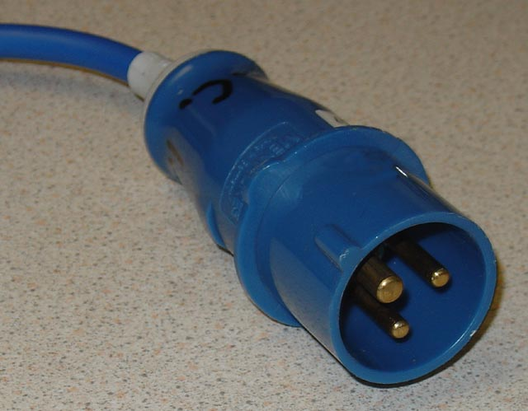
P+N+E Plug (200-250 V)

The objective is to perform flux measurement following a regular grid, depending on the area of the field. Common grid intervals are 10x10m or 20x20m.
By using geostatistical methods (semi-variogram + Kriging) the data will be processed in order to obtain isoflux maps and an estimation of the total output of the area of analyzed gases.

- Implementaton: timetable, budget, distribution of work

Two people of WEST Systems will be present for the campaign in the days between 24th and 28th June 2013.
The total cost of the transfer is comprised of 500 € for the costs of transport by van and € 500 for overnight stays.

- Expected results and possible risks

The most important expected result of IPNOA project is the development of the two prototypes (fixed and portable) for measuring N2O soil fluxes; the portable version will allow scanning the spatial soil heterogeneity in emissions while the fixed version will be adopted to study temporal variability of emissions related to the environmental conditions and the agri-ecosystem management.
One of the two instruments (N2O, CH4, CO2) will provide useful data for the construction of a middle-detail map of the investigation area, while the second one (CH4, CO2) will be used to the map integration.
This data will provide an estimation of the total gas emissions from the investigation area.
Results from this campaign will foremost be applicable for the method inter-comparison as outlined above. Conclusions from this work will inevitably be useful for future development and fine-tuning of greenhouse gas flux methods, and will consequently contribute to improve current estimates of GHG balances and to export this innovative approach in other regions and countries.

- Key literature

IPPC, 2007. Fourth Assessment Report, Working Group I. Climate Change 2007: The Physical Science Basis. Coupling between Changes in the Climate System and Biogeochemistry (Chapter 7). Cambridge University Press, Cambridge/UK/New York, NY, USA.
Mosier A., Kroeze C., Nevison C., Oenema O., Seitzinger S. and van Cleemput O. Closing the global N2O budget: nitrous oxide emissions through the agricultural nitrogen cycle Nutrient Cycling in Agroecosystems 52: 225-248, 1998.
Kroeze C., Mosier A., Bowman L., 1999. Closing the global N2O budget: a retrospective analysis 1500-1994. Global Biogeochemical Cycles, v. 13, (1), 1-8.
Laville P., Lehuger S., Loubet B., Chaumartin F., Cellier P., 2011. Effect of management, climate and soil conditions on N2O and NO emissions from arable crop rotation using high temporal resolution measurements. Agricultural and Forest meteorology, 151, 228-240.

