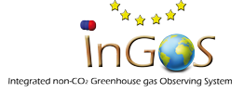InGOS TNA 4 confirmation

Confirmation of receipt of gas cylinders

[Name of Project Leader], Confirms the receipt of ….. cylinders on date ……. as requested in TNA request [TNA request id]

Signed

Date

Location

