InGOS – Integrated non-CO₂ Observing System

- Project name (acronym), name and contact information of the researcher(s), duration of the project (dates, number of working days), type and name of the infrastructure requested
Project name: Spectronus
Name and contact of the researcher: Marie Laborde, hoehtalstrasse 15a, ennetbaden, Switzerland. Employed by AerosolconsultingML, ennetbaden 5408, Switzerland. Email: marie.laborde@aerosolconsulting.com. Phone: 0041767559648
Duration of the stay: I would like to stay 2 weeks on site, from the 2rd June until the 16th june, so 15 RWD.
The infrastructure I would like to get access to is the easter bush, UK site.

- Background
Soils are known to be the most important source of non-CO2 greenhouse nitrous oxide (N2O). The amount of N2O produced by the soil varies greatly in space and time due to the microbiological nature of the production process. Indeed N2O emissions are tightly linked to e.g. the soil temperature, wetness, pH, to the amount of rainfall and to the amount of nitrogen fertilization. N2O inventories are currently therefore highly uncertain and with it the impact of N2O of the earth climate (IPCC,2006).
In order to decrease this uncertainty, it is therefore important to measure accurately N2O fluxes emitted by different type of soils and at different time of the year.

Several methods are currently available to measure the N2O fluxes release by soils. N2O fluxes measured with chambers are rather inexpensive but remain uncertain due to the limited amount of measurement points both in time and in space (Jones, 2011).
Fluxes measured with micrometeorological methods are more expensive but allow a more in depth understanding of the processes by measuring in a medium to long term and retrieving seasonal variation and time series of N2O concentration (Jones, 2011).
In addition, both methods use different type of instruments, increasing the need for the different system to be standardized and compared.
In order to do so an intercomparison of numerous available measurement methods is needed. This intercomparison would preferably involve all the available methods measuring side by side.

Some previous publications have addressed that issue by comparing a few methods (Jones, 2011) but the constant improvement in the technique and the release of new product calls for a new intercomparison.

- Objectives
Fertilizer N applications to grassland are often required to achieve optimum yields, however a byproduct of this increasingly widespread agronomic practice is atmospheric pollution in the form of nitrous oxide (N2O) emissions. This trace gas is implicated in the destruction of stratospheric ozone and acts as a greenhouse gases, making essential the collection of inventories and the development of a refined understanding of the processes that regulate N2O emissions. This is especially important for ecosystems where N2O emissions are greatly amplified on a per unit area basis by routine additions of fertilizer N, such as the grassland system.

The objectif of this project is to compare the measurement of N2O fluxes obtained with the combination of a REA and the spectronus FTIR trace gas analyser to other common methods used around the INGOS network, in a realistic way, i.e. while measuring N2O fluxes from a fertilized grassland field.
This intercomparison will allow the community to assess the accuracy, the repeatability, the robustness but also the limitations of the Spectronus trace gas analyser. The result of this intercomparison is also therefore important for the community in order to compare results from different publications, using different techniques.

This intercomparison should also help the INGOS community in achieving one of its goals: optimizing and standardizing the measurement of N2O.

This project would require the access to the Easter Bush (TNA1 supersite, Edinburgh, UK) site during the N2O intercomparison campaign planned from the 3rd June-28th June. Indeed, this site and this campaign would allow the Spectronus trace gas analyser to be compared to all the other instruments under realistic conditions, i.e. while measuring background N2O fluxes and N2O fluxes after fertilization of the field.

- Methods and materials (legal and ethical issues)
The intercomparison of the Spectronus trace gas analyser to the other methods will be performed by running the instruments side by side. The background N2O fluxes will first be measured for one week in order to compare the instruments at lower level of N2O followed by 3 weeks of N2O fluxes measurement of the fertilized field.
The calculated fluxes from all the different methods will then be compared and the different instrument capabilities assessed.

The spectronus trace gas analyser will be lent by AerosolConsultingML GmbH and combined with a REA system from the ECN-Energy Research Center of the Netherlands (Biomass, Coal and Environmental Research, ECN) and a sampling box from the University of Bremen (Institute of Environmental Physics, University of Bremen, Bremen, Germany) in order to achieve N2O fluxes measurement.
Bags will be filled up (using the REA system) according to the direction of the wind. While pair of bags (one for the up wind and one for the down wind) are filled up, another pair of bags will be analysed using the Spectronus trace gas analyser. The switch between bags will be insured by the sampling box designed by the university of Bremen.

The following setup will be used in order to achieve this measurement:
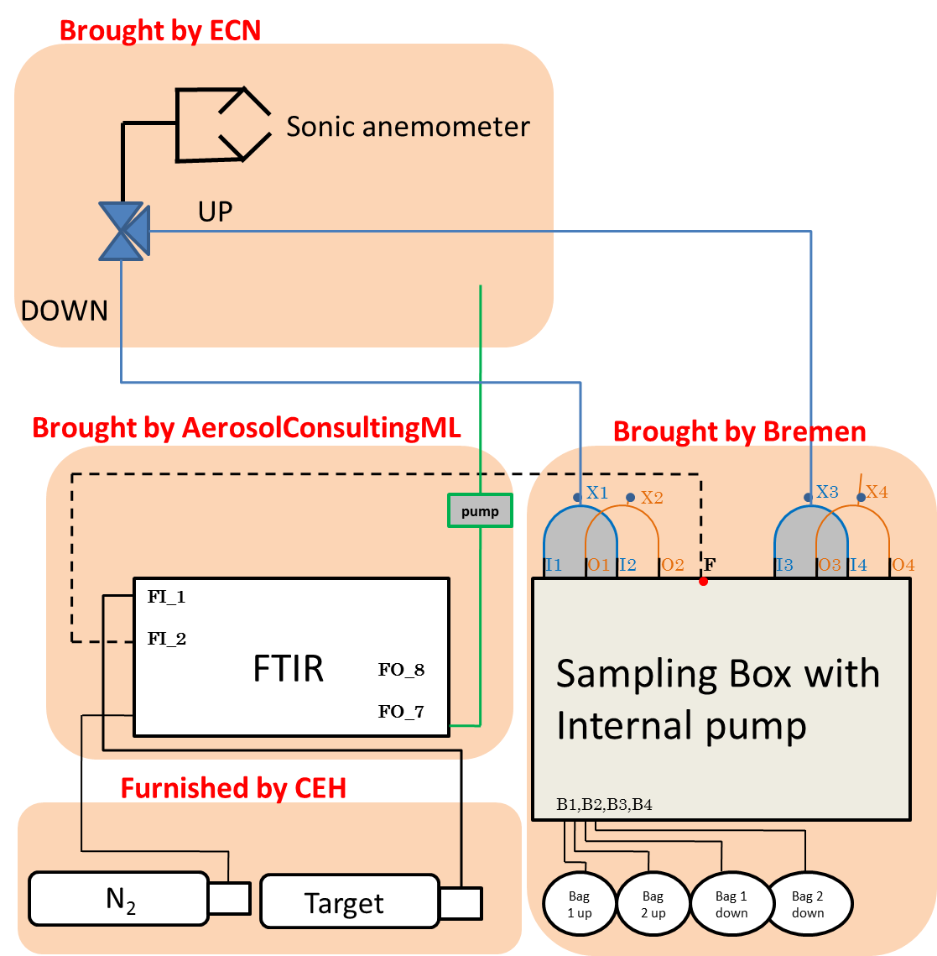

Figure 1: Setup of the Spectronus trace gas analyser during N2O intercomparison campaign.
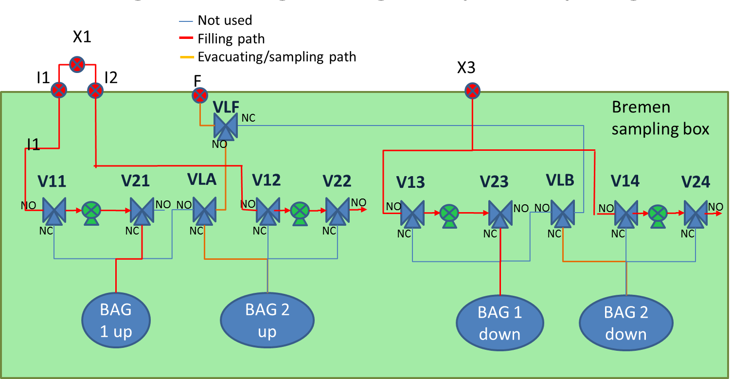
Figure 2: Plumbing diagram. The bags number 1 are filled up while the bag 2 up is being analyser with the Spectronus.

- Implementaton: timetable, budget, distribution of work

The following tasks are planned as described in the table.

task | Starting date | End date | Location | Responsible person
Initial setup of the instruments – REA + Spectronus + sampling box | 21/05/2013 | 25/05/2013 | ECN | Alex Vermuelen
Shipment instrument (ferry) | 02/06/2013 | 02/06/2013 | n/a | Alex Vermuelen
Setup of the instruments at easter bush | 02/06/2013 | 04/06/2013 | CEH | Alex / Marie
Background measurement | 4/06/2013 | 8/06/2013 | CEH | Alex/Marie
Measurement of fertilized grassland | 8/06/2013 | 28/06/2013 | CEH | Alex/Marie
Packup | 28/06/2013 | 28/06/2013 | CEH | Alex

name | 2 | 3 | 4 | 5 | 6 | 7 | 8 | 9 | 10 | 11 | 12 | 13 | 14 | 15 | 16 | 17 | 18 | 19 | 20 | 21 | 22 | 23 | 24 | 25 | 26 | 27 | 28
marie
Alex
Pim
CEH
I plan to go on site from the 2/06/2013 until the 16/06/2013. The following table summarise the people present at CEH (in green) and the need for help from CEH (technical support in red and surveillance in orange).
The combinaison of green and orange identified the time period when, depending on the state of the instrument, it may run alone with the responsible person (Marie laborde and Alex Vermuelen) checking it remotely.

The travel expense claimed includes the travel to Amsterdam (~100euros) from Zurich for the initial setup and the travel to Edinburgh (150Euros) for the campaign along with the daily allowance of 50 euros covering part of the hotel and food.

- Expected results and possible risks
As previously mentioned, the results from this intercomparison will allow the non-CO2 greehouse gases community to assess the accuracy, the repeatability, the robustness but also the limitations of the Spectronus trace gas analyser. The results of this intercomparison are also therefore important for the community in order to compare results from different publications, using different techniques.

This intercomparison will also help the INGOS community in achieving one of its goals: optimizing and standardizing the measurement of N2O.

- Key literature
S. K. Jones et al.: Nitrous oxide emissions from managed grassland: a comparison of eddy covariance and static chamber measurements. Atmos. Meas. Tech., 4, 2179–2194, 2011

J. T. Houghton, Y. Ding, D. J. Griggs, M. Noguer, P. J. van der Linden, X. Dai,
K. Maskell, and C. A. Johnson, editors. Intergovernmental Panel on Climate Change:
Climate Change 2001: The Scienti_c Basis: Contribution of Working Group I to the
Third Assessment Report of the Intergovernmental Panel on Climate Change. Alphascript
Publishing, 2001. ISBN 6130051670. URL http://www.worldcat.org/isbn/
6130051670.

