InGOS – Integrated non-CO₂ Observing System

TNA 1 Application by Greenhouse Gas Laboratory, Department of Earth Sciences (GGLES), Royal Holloway, University of London to visit Cabauw supersite, Netherlands

- Project name: AUTOCAB
Name and contact information of the researcher(s): Dr. Dave Lowry, Ms. Giulia Zazzeri (research student), Department of Earth Sciences (GGLES), Royal Holloway, University of London, Egham, Surrey TW20 0EX, UK
Duration of the project:17/11/14 to 19/11/14, 2 working days
Name of Site: Cabauw supersite, lowest level air intake

- Background
  - Significance of the research: This research furthers collaborations between Univ. Utrecht, EMPA and RHUL through TNA5 and JRA4 workpackages of InGOS. Currently there is an intercomparison of new isotopic instruments that measure methane, which is taking place at Cabauw. At RHUL we measure the carbon-13 of methane to high precision, mostly on samples collected at field sites. Samples were collected for us at the recent Dubendorf intercomparison campaign over many days and our results show a comparable isotopic trend to the Univ Utrecht instrument, with a relatively constant offset that can be attributed to calibration links to different laboratories. This highlighted a) the good quality of the data being produced by the new instruments, and b) the need for central calibration across Europe. The new experiment will further this important intercomparison, but help to answer a significant scientific question regarding the isotopic signature of methane emissions emanating from NW Europe.
  - Links with current research of the applicant: The applicants have been studying the isotopic signatures of methane sources in SE England for the last 3 years, and have studied the signatures for air masses reaching the east coast of the UK from the Netherlands and Belgium. Analysed 48 bag samples for methane concentration and isotopic signature collected during the recent Dubendorf intercomparison campaign.

- Objectives
  - The objectives of the site visit are to collect air samples in Tedlar bags from the same air inlet being used by the instrument collaboration experiment at the Cabauw site, at hourly intervals over 2 consecutive diurnal cycles by using the RHUL auto-sampler. The samples will subsequently be analysed at the RHUL laboratory.
  - This work is closely linked to the objectives of JRA4, which include the testing and validation of new isotopic measurement techniques.

- Methods and materials (legal and ethical issues)
RHUL will bring a 20-bag auto-sampler to the Cabauw tower site to fill a sample bag with air every 1 hour over 2 nights, for subsequent laboratory isotopic analysis. A flow of air from the inlet is required that is greater than the flow of the auto-inlet. The autoinlet pump will pull air through the sampler every hour from a tee into the main air line. A 220-240V power supply is required to run, pump, inlet valve control and laptop computer. The system is in sleep mode except for each hour when the pump and valves are operated to fill the Tedlar bag. The auto-inlet can be placed on the floor or a solid table. It has a base dimension of 90 x 60 cm. It has been used successfully many times on a central London rooftop and is inherently safe. Valves and pump are not activated for sufficient time to create heat. Once the sampling has started there is no requirement for the applicants or facility personnel to remain at the site during the experiment.

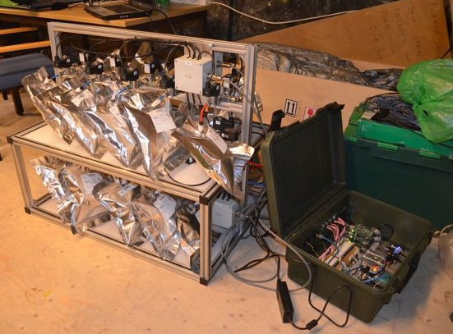
Autosampler and control module with filled Flexfoil bags at the central London rooftop site.

- Implementation: timetable, budget, distribution of work
  - Timetable for the research including personnel efforts: Lowry will be responsible for plumbing and testing connections of the autosampler. Zazzeri will set up the sampling routine and activate software sequences. Twenty tedlar bags will be attached to the auto-sampler in mid-afternoon to start sampling at 16:00 on Nov 17. The filled bags will be removed at 11:00 on Nov 18 and a second set of 20 attached for filling to commence at 14:00 for removal at 09:00 on Nov 19.
  - Total budget for travel and logistical support as requested: The total budget requested for the campaign is €500 euro. This includes €200 for a return Eurotunnel ticket, €100 for diesel between London and Cabauw, and €50 x 2 days x 2 persons as the per diem allowance for the 2 participants. The time of the visit has been chosen because there will be scientists at the site on days when sample collection will take place. Once the auto-sampler has been connected to an air inlet line, bags connected to each port, the program started and sampling frequency selected, then the bags can be left for automatic filling.
  - Plan for specific logistical needs: Access to the site is required during daytime. Internet connection would be preferable but not essential.

- Expected results and possible risks
  - Expected scientific impact of the research: This experiment will: a) provide part of the external validation procedure of new instrumentation currently being tested at Cabauw, and b) it will confirm findings from eastern UK studies, which suggest that there is a well-defined averaged isotopic signature for methane emissions emanating from NW continental Europe.
  - Applicability and feasibility of the research results: The only risk associated with the experiment is the possibility of up to 5% loss of samples before they can be analysed in the laboratory. This will not make a significant difference to the interpretation of the data, or the comparison between measurement techniques.
  - Publication plan: The results from the campaign will form part of a joint publication with JRA4 colleagues studying the instrument intercomparison. RHUL will use the data in a planned publication at the end of InGOS TNA5 analysis, which will focus on regional changes in the isotopic signatures of methane emissions between western and central Europe.
  - Data access plan: Data will be provided to JRA4 partners carrying out detailed analysis of continuous measurement instruments and for them to disseminate with their own data.

- Key literature
- I. Levin, H. Glatzel‐Mattheier, T. Marik, M. Cuntz, M. Schmidt, D.E. Worthy, (1999) Verification of German methane emission inventories and their recent changes based on atmospheric observations, Journal of Geophysical Research: Atmospheres (1984–2012) 104(1999) 3447-3456
- D. Lowry, C.W. Holmes, N.D. Rata, P. O'Brien, E.G. Nisbet, (2001) London methane emissions: Use of diurnal changes in concentration and δ¹³C to identify urban sources and verify inventories, Journal of Geophysical Research: Atmospheres 106, 7427-7448.
- R. Fisher, D. Lowry, O. Wilkin, S. Sriskantharajah, E.G. Nisbet, (2006) High-precision, automated stable isotope analysis of atmospheric methane and carbon dioxide using continuous-flow isotope-ratio mass spectrometry: Rapid Communications in Mass Spectrometry, v. 20, p. 200-208.
- A. Townsend-Small, S.C. Tyler, D.E. Pataki, X.M. Xu, L.E. Christensen, (2012) Isotopic measurements of atmospheric methane in Los Angeles, California, USA: Influence of "fugitive" fossil fuel emissions, Journal of Geophysical Research-Atmospheres 117.
- G. Zazzeri, D. Lowry, R.E. Fisher, J.L. France, M. Lanoisellé and E.G. Nisbet, (submitted, 2014) Plume mapping and isotopic characterisation of anthropogenic methane sources. Atmospheric Environment.

