InGOS TNA 1-2 Activity Report

Methane fluxes of Phragmites australis under different climates
(CH4-Phragmites)
Bogdan Chojnick

Id 640

Please limit the report to max 3-5 pages, including tables and figures.
The report should be sent as a pdf document and include the following subheadings:

- Introduction and motivation
Wetlands store 25%-30% of the global soil carbon pool (Millennium-Ecosystem-Assessment 2005) and are important CO₂ sinks. In addition, wetlands act as sources for greenhouse gases (GHG) by emitting methane (CH₄) to the atmosphere. In this context, the function of wetlands in relation to global warming will be the balance between net CO₂ assimilation and CH₄ emission. With global warming, wetlands have the potential to release stored carbon, because of the high temperature sensitivity of microbial respiration (Davidson and Janssens 2006), and contribute to the increase of atmospheric CO₂ concentrations. However, it is still unknown whether wetlands will convert from long-term carbon sinks to sources as a result of global warming and other anthropogenic effects by increasing the emission of CH₄ and decreasing the assimilation of CO₂ via photosynthetic processes.
Phragmites australis is one of the most common species found in wetlands and is considered the most widespread and productive wetland plant species in the world (Brix et al. 2001; Zhou et al. 2009). Similar to other ecosystem functioning, studies about Phragmites australis have found that, the differences in the rate of net ecosystem CO₂ exchange is related to the photosynthetic active radiation (PAR) flux density whereas ecosystem respiration is mostly related to temperature and soil water content (Zhou et al. 2009). However there are no studies regarding CH₄ fluxes and their main meteorological drivers in wetlands dominated by Phragmites.
The eddy covariance technique (EC) is used worldwide to measure CO₂ exchange and water vapor by "flux towers" (Baldocchi et al. 2001) at the ecosystem level. In addition, the recent development of CH₄ gas analyzers to measure CH₄ at fast response has opened the possibility to investigate properly CH4 fluxes at the ecosystem-scale. However, due to its earlier development, few publications regarding comparison between IRGAs for measuring CH₄ fluxes were published (Peltola et al. 2013).
In this context, this project proposes to analyses the GHG exchange (mainly CH₄) of two wetlands with Phragmites australis as the dominant species under different climates using the eddy covariance technique and two different CH₄ analyzers (LI-7700 and DLT-100 Fast Methane Analyser (Los Gatos)). The first site, Padul, is located in southern Spain in a sub-humid warm climate, characterized by a mean annual temperature of 16ºC and total annual precipitation of ca. 470 mm. CH₄ fluxes are measured by an LI-7700 since January 2013. The second site, Rzecin is located in Poland with a mean annual temperature of 8ºC, and a total annual precipitation around 600mm with no dry season. CH₄ fluxes are measured by Los Gatos methane gas analyzer and by a LI-7700 (owned by the CSIC (Spain)), that was installed in the Rzecin site in June 2013.
- Scientific objectives
The objectives of this project are (1) a field intercomparison of two CH₄ gas analyzers (LI-7700 vs. Los Gatos) suitable for EC fluxes and (2) analysis of GHG fluxes of Phragmites australis under different climates.
- Reason for choosing station
For the first objective, we are going to analyze the CH₄ fluxes measured by the LI-7700 (owned by the University of Granada (Spain)), that was installed in the Rzecin site in June 2013 and compare these results with those measured by Los Gatos system. In addition, similar to the Padul site, the Rzecin site is dominated by Phragmites australis (for WD from 330º to 30º) allowing the possibility to compare GHG fluxes of such vegetation under different climates (Objective 2).
- Method and experimental set-up
The proposed objectives will be reached by obtaining (after standardizing procedures) and comparing the final CH₄ fluxes measured by Los Gatos and the LI-7700 installed in Rzecin. After this comparison we will be able to compare the CH₄ fluxes measured by the LI-7700 in the Padul site and the Los Gatos analyzer in Rzecin and analyze changes in CH₄ fluxes measured in Phragmites due to different climate conditions. For this purpose, the main instrumentation used in this project will be the Los Gatos analyzer and the two LI-7700, previously installed by the applicant, in the Rzecin and Padul sites.
- Preliminary results and conclusions
Comparison of CH₄ fluxes measured by the LI-7700 and DLT-100 Fast Methane Analyser (Los Gatos) in the Rzecin site.
During my stay in Poznan we processed the CH4 flux data of Rzecin (from end of May to end of July 2013) using the EddyPro program and the following processing options: double rotation, Block average for detrending method, covariance maximization for time lag detection. In addition, the WPL term (Web et al., 1980) was implemented as an a posteriori correction for the LI-7700 open path analyzer, whereas for Los Gatos analyzer the formulation proposed by Ibrom et al., 2007 was applied.
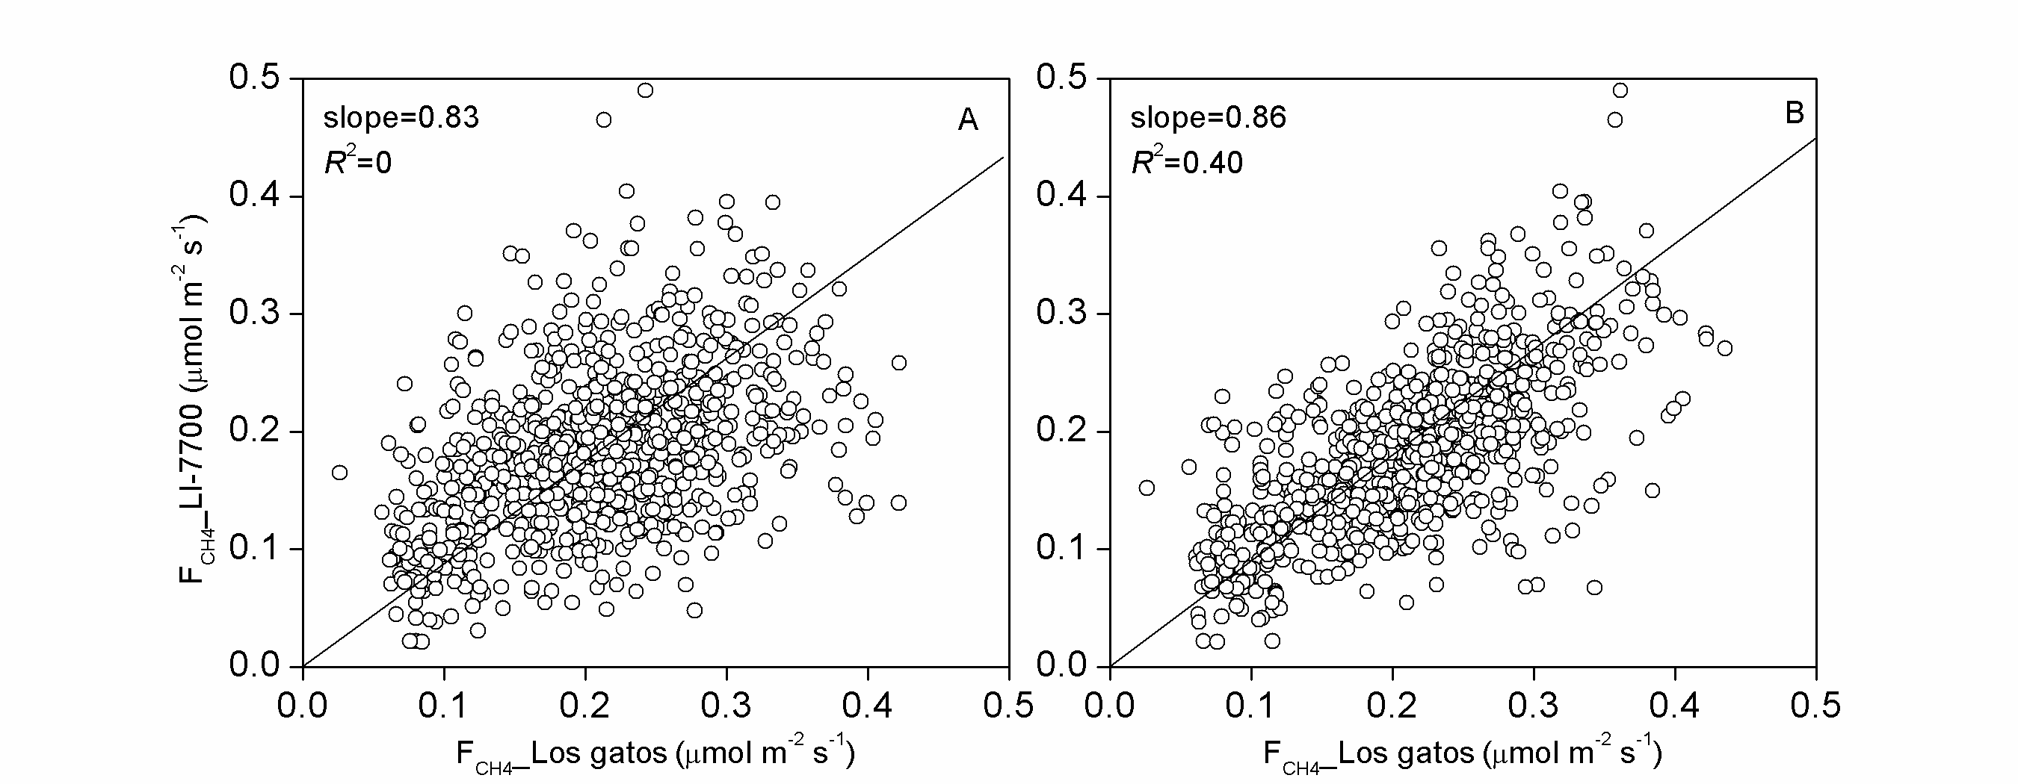
Figure 1. Correlation of CH₄ fluxes measured with both instruments at Rzecin peatland
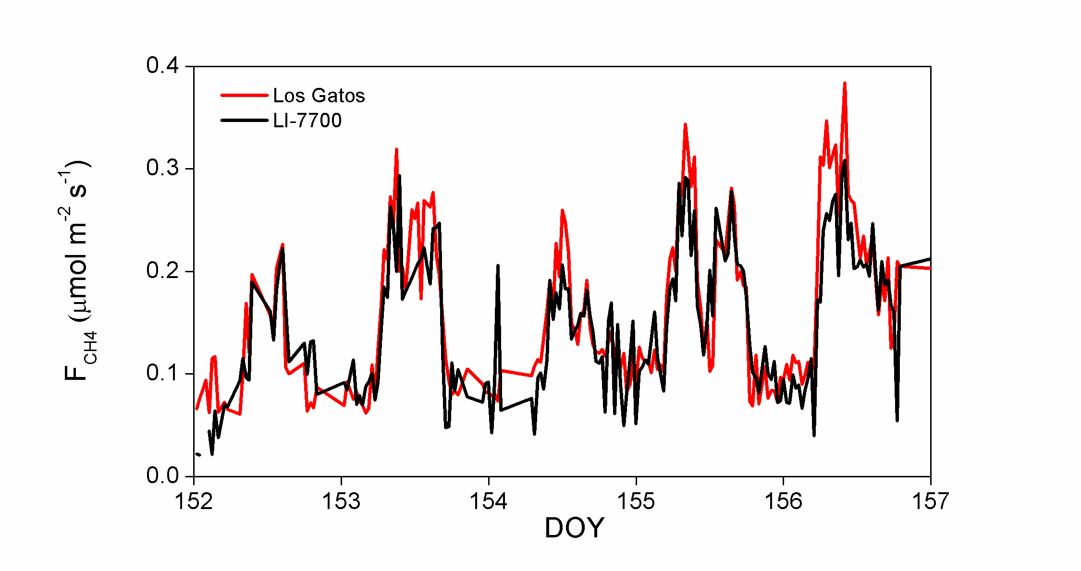
Figure 2. Daily patterns of methane fluxes measure with both instruments at Rzecin peatland

Figure 1 and 2 shows the correlation and time series of CH₄ fluxes respectively. Only data with quality 0 according to EddyPro was selected for this study. The results of the comparison were not as successful as we expected (Figure 1A; slope=0.83, R²=0). However, if we artificially include a delay of 2 hours in the fluxes measured by the LI-7700 the correlation is improved (Figure 1B; slope=0.86, R²=0.45). This suggests some mistakes in the procedures for calculating the fluxes that needs to be solved.
Analysis of GHG fluxes of Phragmites australis under different climates
During my stay in Poznan we also worked analyzing the database for both sites (Padul and Rzecin) and preparing the outline and figures and tables for a future paper focused on: “GHG fluxes of Phragmites australis under different climate conditions”.
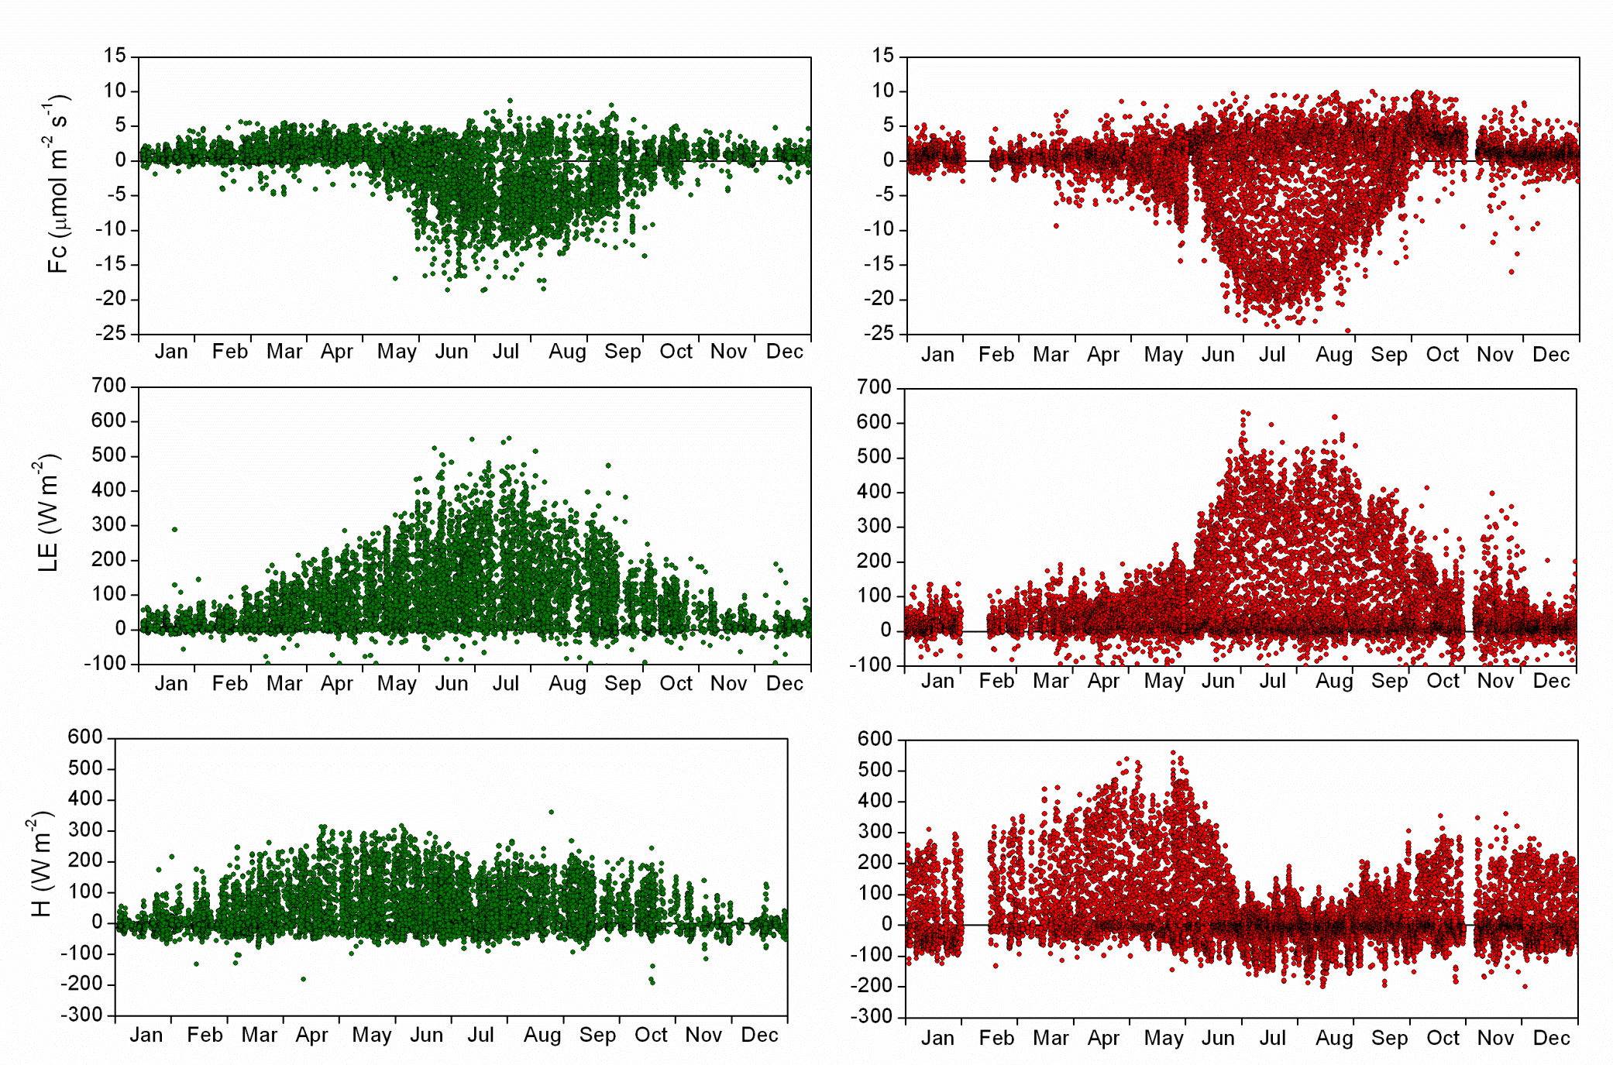
Figure 2. Annual trends of CO₂ fluxes and Latent and Sensible heat flux for the two study sites. For the Padul site (red colour) half hourly fluxes of 2012 and 2013 are shown (n=14391), whereas for the Rzecin site (green colour) half hourly fluxes coming from 330º to 30º (main wind direction for Phragmites australis) from 2004 to 2013 are selected (n=9364).

Despite great differences in meteorological conditions, Phragmites australis starts their growing season (net CO₂ flux uptake and higher values of latent heat fluxes) in the same period (from June to August) (Figure 2). However, for our study case, warmer weather (double temperatures) induced an increase in net CO₂ uptake and release during the daytime and nighttime respectively, during the growing season. In addition, values of LE are 20% higher in the Padul site during this period. Whereas for non-growing periods similar values of net CO₂ release and LE where measured for both sites (Figure 2). By contrast, sensible heat flux (H) presented different patterns between sites. For the Rzecin site the values of H are around 250 W m⁻² during the whole year (with an exception in winter). Whereas values of H in the Padul site presented a marked seasonal effect. Winter and autumns presented values of H around 250 W m⁻², such values increase up to 550 in spring and turned to even negative values during summer (Figure 2).

Winter Spring Summer Autumn
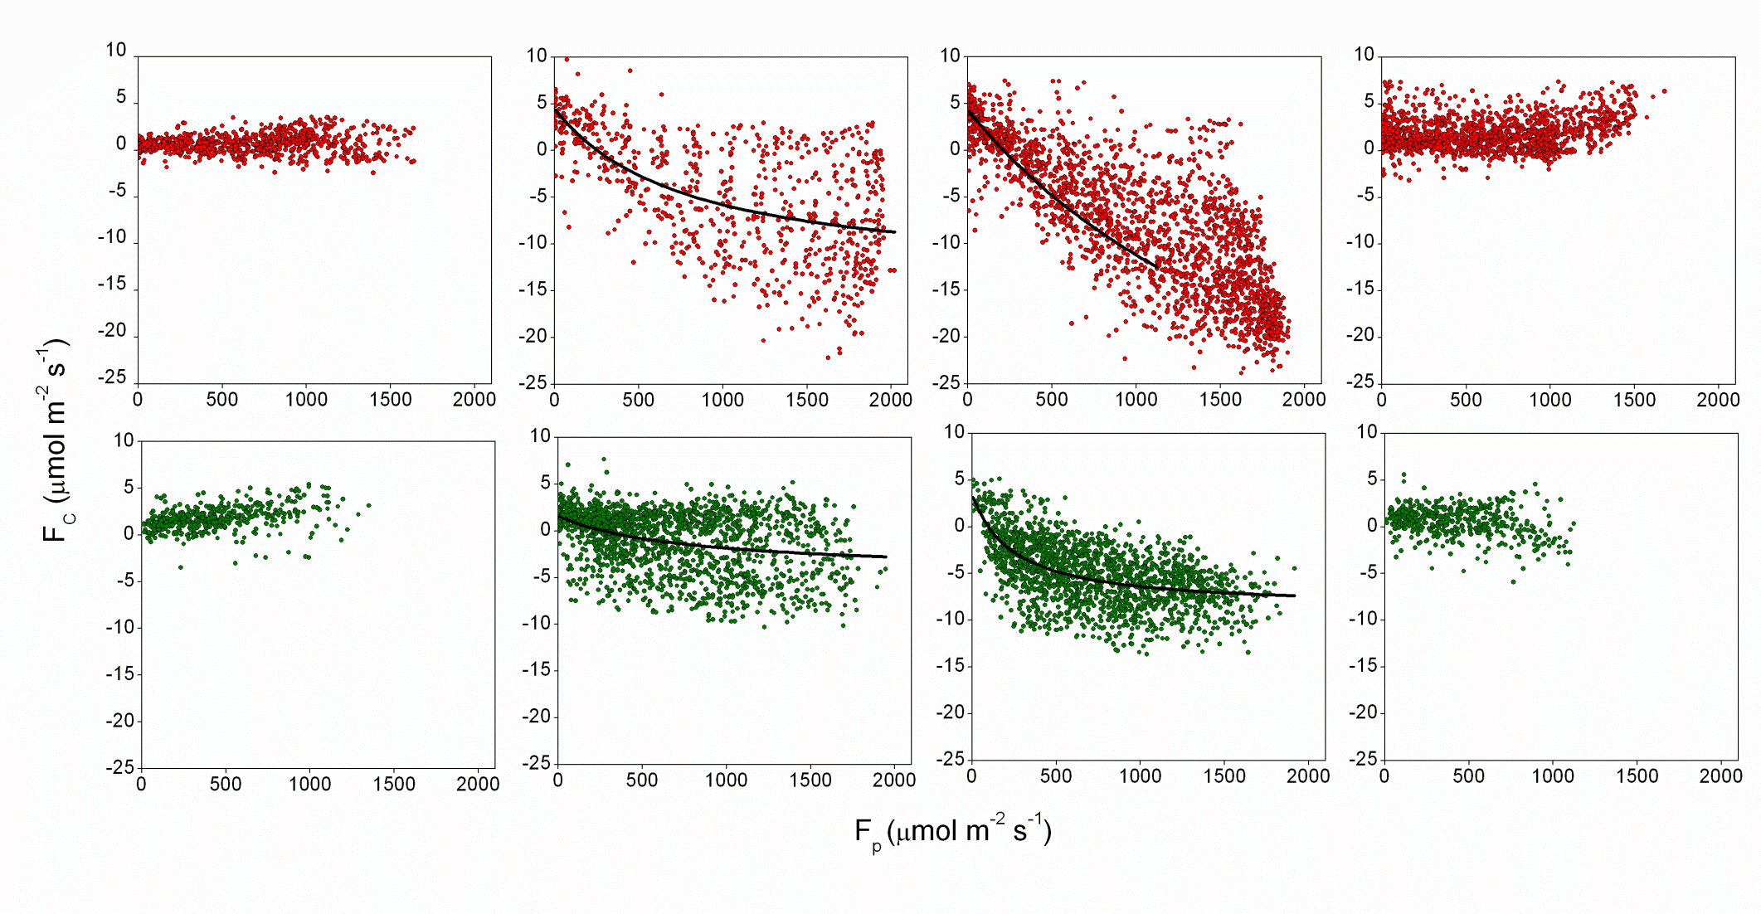
Figure 3. Seasonal dependence of daytime CO₂ fluxes (F_{C}) on light (F_{P}) for the Padul (red colour) and Rzecin site (green colour)

Regarding the processes involve in NEE, We examined the influence of environmental variables on daytime (F_{P} >10 μmol m-2 s-1) ecosystem gas exchange and tested the ability of an empirical ecophysiological model based on F_{P} to estimate carbon fluxes.
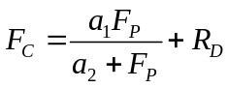
where a₁ and a₂ [μmol m⁻² s⁻¹] are constants and R_{D} [μmol m⁻² s⁻¹] represents daytime respiration. The ecophysiological interpretation of fitted model parameters describes a₁ as the maximum photosynthetic uptake, and a₁/a₂ the initial slope of the light response, sometimes termed apparent quantum yield or efficiency (Suyker and Verma 2001).
As results, the daytime ecosystem fluxes showed strong seasonality for both sites. Figure 3 presents relationships between F_{C} and F_{P} over every season. The empirical hyperbolic model (light response) that we used described the data quite well in spring and summer (Table 1) for both sites. However, during winter and autumn photosynthesis processes did not occur and the model was clearly inadequate (Table 1).

 | Padul (Spain) |  |  |  | Rzecin (Poland)
 | R_{D} | a₁ | a₂ | R² | R_{D} | a₁ | a₂ | R²
Winter | - | - | - | - | - | - | - | -
Spring | 4.5±0.7 | -18±1 | 800±200 | 0.36 | 1.6±0.3 | -6.0±0.7 | 800±300 | 0.12
Summer | 4.3±0.4 | -51±4 | 2300±300 | 0.86 | 3.5±0.7 | -13.3±0.6 | 240±40 | 0.32
Autumn | - | - | - | - | - | - | - | -
Table 1. Seasonal values of the parameters (units: μmol m⁻² s⁻¹) and R² of the empirical ecophysiological model based on F_{P} to estimate carbon fluxes for both sites.

 | Padul (Spain) |  |  | Rzecin (Poland)
 | F_{CH4} | F_{C} | LE | F_{CH4} | F_{C} | LE
Winter | - | 1±1 (1900) | 23±32 (2249) | - | 1±1 (2209) | 23±35 (2249)
Spring | 0.8±0.5 (899) | -1±4 (3869) | 67±91 (3871) | 0.1±0.1 (341) | 0±4 (3244) | 106±96 (3309)
Summer | 0.3±0.4 (393) | -3±8 (4128) | 131±155 (4209) | 0.2±0.1 (339) | -3±6 (2707) | 129±111 (2728)
Autumn | - | 2±2 (3541) | 32±59 (3902) | - | 1±1 (1204) | -
Table 2. Seasonal average values ±SD (number of samples) of GHG fluxes for both sites. Units: F_{CH4} and F_{C} in μmol m⁻² s⁻¹; LE in W m⁻²

Methane fluxes were also analyzed in spring and summer for both sites. The highest emissions were measure in the Padul site in spring with average values of 0.8±0.5 μmol m⁻² s⁻¹ whereas Rzecin emitted 0.1±0.5μmol m⁻² s⁻¹ on average during the same period. In summer, methane emissions decrease nearly 3 times in Padul and similar values that the previous season was measured in Rzecin.
As preliminary conclusions, Phragmites australis starts their growing season (net CO₂ flux uptake) in the same period for both sites. However, strong differences of GHG fluxes were measured. The warmer weather in Padul (double temperatures) induced an increase in net CO2 uptake and release during the daytime and nighttime respectively, during the growing season. Whereas for non-growing periods similar values of net CO₂ release were measured for both sites. In addition, preliminary analysis based on hyperbolic models suggest higher efficiency of net photosynthesis in the warmer site (Padul). Methane emissions were also higher in the Padul site during spring, whereas similar values were measured in summer. However, more information regarding climatic conditions, soil properties, nutrient and biomass are needed for explaining the differences in fluxes. In this context, during my stay in Poznan we also promoted a field campaign in Rzecin for measuring the maximum shoot’s density of Phragmites in the growing season and the same procedure is going to be applied in the Padul site
- Outcome and future studies
- To re-check the procedure for calculating methane fluxes of the LI-7700 and Los Gatos with EddyPro
- To compare the methane fluxes measured by both instruments for different stability conditions.
- To organise a field campaign in Rzecin for measuring the maximum density of Phragmites in the growing season
- To analyse the climatic conditions for both sites
- To continue the discussion of results for the future publication
- References
Baldocchi DD et al. (2001) FLUXNET: A new tool to study the temporal and spatial variability of ecosystem-scale carbon dioxide, water vapor, and energy flux densities. Bulletin of the American Meteorological Society 82: 2415–2434
Brix H, Sorrell BK, Lorenzen B (2001) Are Phragmites-dominated wetlands a net source or net sink of greenhouse gases? . Aquatic Botany 69:313-324
Davidson EA, Janssens IA (2006) Temperature sensitivity of soil carbon decomposition and feedbacks to climate change. Nature 440:165-173
Millennium-Ecosystem-Assessment (2005) Ecosystems and Human Well-being: Wetlands and Water Synthesis. , Washington, D. C.
Peltola O, Mammarella I, Haapanala S, Burba G, Vesala T (2013) Field intercomparison of four methane gas analyzers suitable for eddy covariance flux measurements. Biogeosciences 10:3749-3765
Suyker AE, Verma SB (2001) Year-round observations of the net ecosystem exchange of carbon dioxide in a native tallgrass prairie. Global Change Biology 7:279 - 289
Zhou L, Zhou G, Jia Q (2009) Annual cycle of CO 2 exchange over a reed (Phragmites australis) wetland in Northeast China
Aquatic Botany 91:91-98

